ARTIFICIAL INTELLIGENCE
3. Solving Problems by Searching
3.1 Definition, State space representation, Problem as a state space search, Problem formulation, Well-defined problems
3.2 Solving Problems by Searching, Performance evaluation of search strategies, Time Complexity, Space Complexity, Completeness, Optimality
3.3 Uninformed Search: Depth First Search, Breadth First Search, Depth Limited Search, Iterative Deepening Search, Uniform Cost Search, Bidirectional Search
3.4 Informed Search: Heuristic Function, Admissible Heuristic, Informed Search Technique, Greedy Best First Search, A* Search, Local Search: Hill Climbing Search, Simulated Annealing Search, Optimization: Genetic Algorithm
3.5 Game Playing, Adversarial Search Techniques, Mini-max Search, Alpha-Beta Pruning
PAST QUESTIONS:
- Define chromosome, selection, fitness function, cross over and mutation as used in Genetic Algorithm. Explain how Genetic Algorithm in works. (D22, M23, D23)
- Explain A* algorithm in detail. (D22)
- Explain Alpha-beta pruning algorithm. Apply alpha beta pruning on following example considering first node as MAX. (D22)
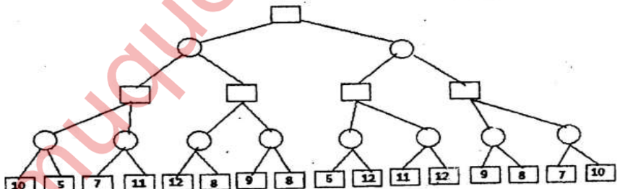
- Explain hill climbing algorithm with example. Explain the problems faced by hill climbing algorithm. (D22, M23)
- Explain Alpha Beta pruning with example. (M23)
- Explain Iterative Deepening Search Algorithm based on performance measure. (M23)
- Explain problems faced by Hill Climbing algorithm. (D23)
- Explain A* algorithm with an example. Also discuss its performance. (D23)
- What is formulation of a problem? Formulate 8-Puzzle problem in terms of following components: initial state, actions, successor function, goal test and path cost. (D23)
- Explain Alpha-beta pruning algorithm. Apply alpha beta pruning on the following example considering the first node as MAX. (D23)
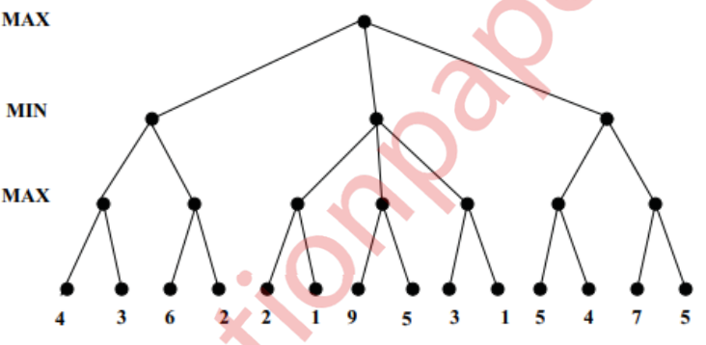

NOTES:

*Problem Formulation :-
Problem formulation is the basic step of problem solving agent where problems defined by using five components.
Problem can be defined formally using five components as follows:
1. Initial state
2. Actions
3. Successor function / Transition Model
4. Goal test
5. Path cost

1. Initial state : The initial state is the one in which the agent starts in.
2. Actions: It is the set of actions that can be executed or applicable in all possible states. A description of what each action does.
3. Successor function/Transition Model : It is a function that returns a state on executing an action on the current state.
4. Goal test : It's a test to see if the present state is a goal state or not. In some cases, a goal test can be performed simply by comparing the current state to the declared goal state, which is known as an explicit goal test. The implicit goal test is used when the state of a problem cannot be described directly and must be generated by doing some computations.
Example:
In Tic-Tac-Toe game making diagonal or vertical or horizontal combination declares the winning state which can be compared explicitly, but
In case of chess game, the goal state cannot be predefined but it’s a scenario called as “Checkmate” which has to be evaluated implicitly.
5. Path cost : It is simply the cost associated with each step to be taken to reach to the goal state. To determine the cost to reach to each state, there is a cost function, which is chosen by the problem solving agent.

8 PUZZLE PROBLEM –
The 8-puzzle, an instance of which is shown in Figure, consists of a 3×3 board with eight numbered tiles and a blank space. A tile adjacent to the blank space can slide into the space. The object is to reach a specified goal state, such as the one shown on the right of the figure.
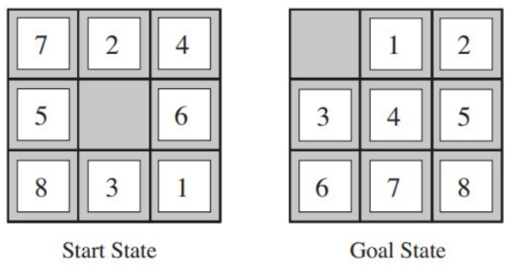
The standard formulation is as follows:
- States: A state description specifies the location of each of the eight tiles and the blank in one of the nine squares.
- Initial state: Any state can be designated as the initial state. Note that any given goal can be reached from exactly half of the possible initial states.
- Actions: The simplest formulation defines the actions as movements of the blank space Left, Right, Up, or Down. Different subsets of these are possible depending on where the blank is.
- Transition model: Given a state and action, this returns the resulting state; for example, if we apply Left to the start state in Figure, the resulting state has the 5 and the blank switched.
- Goal test: This checks whether the state matches the goal configuration shown in Figure. (Other goal configurations are possible.)
- Path cost: Each step costs 1, so the path cost is the number of steps in the path.

8 QUEEN PROBLEM –
The 8 Queens problem is the problem of placing eight queens on an 8x8 chessboard such that none of them attack one another
- States : Any arrangement of 0 to 8 queens on the boards is a state.
- Initial state : Empty board i.e. No queens on the board.
- Actions : Adding a queen to any empty square.
- Transition model : Returns the board with a queen added to the specified square.
- Goal test : 8 queen are on the board, in such a way that none is in attacking position.
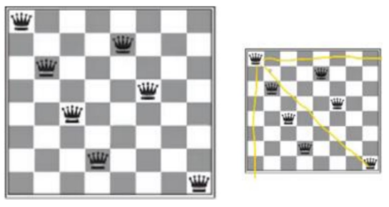
*Uninformed Search algorithms :-
It is also known as blind search. In this strategy only the initial and goal state is given and no additional information is available.
• They do not have any additional information
• Information provided in the problem definition only
• It does not use knowledge in the processing of search.
• It is time consuming for getting the solution.
• It is always complete.
• It is expensive
• It requires moderate time
• It is lengthy for implementation

1. Depth First Search –
Depth-first search is a traversing algorithm used in tree and graph-like data structures. It generally starts by exploring the deepest node in the frontier. Starting at the root node, the algorithm proceeds to search to the deepest level of the search tree until nodes with no successors are reached. Suppose the node with unexpanded successors is encountered then the search backtracks to the next deepest node to explore alternative paths.
Originally it starts at the root node, then it expands all of its one branch until it reaches a dead end, then backtracks to the most recent unexplored node, repeating until all nodes are visited or a specific condition is met.
Implementation –
Depth first search uses a LIFO (Last In First Out) queue (Stack).
- Initialize an empty stack and an empty set for visited vertices.
- Push the start vertex onto the stack.
- DFS Process:
- Start at the given starting node.
- Mark the node as visited.
- Visit all unvisited neighbours of the node (adjacent nodes in the case of an adjacency list or matrix).
- Recursively (or iteratively) apply the same process to the neighbours until all reachable nodes are visited.
- If the loop completes without finding the goal, return "Path not found".
Performance Evaluation
1) Completeness : Complete if DFS explores all the nodes hence it gives the assurance for solution.
2) Optimality : No, as it cannot guarantee the shallowest solution.
3) Time Complexity : DFS requires moderate amount of time to generate all the O(b*m) nodes in the search tree, where m is the maximum depth of any node; this can be much greater than the size of the state space.
4) Space Complexity : To store single path from root to the some node to a particular level, along with unexpanded siblings, when same node gets fully explored, its complete branch i.e, descendants will get removed from the memory. O(b*m)

2. Iterative Deepening Search –
There are two common ways to traverse a graph, BFS and DFS. Considering a Tree (or Graph) of huge height and width, both BFS and DFS are not very efficient due to following reasons.
- DFS first traverse nodes going through one adjacent of root, then next adjacent. The problem with this approach is, if there is a node close to root, but not in first few subtrees explored by DFS, then DFS reaches that node very late. Also, DFS may not find shortest path to a node.
- BFS goes level by level, but requires more space.
IDDFS combines depth-first search’s space-efficiency and breadth-first search’s fast search.
Iterative Deepening Depth First Search (IDDFS) is an algorithm that is an important part of Uniformed BFS and DFS.
It Keeps on incrementing the depth limit by iterating the procedure unless we have reached to the goal node.
Implementation -
• In Iterative Deepening Depth First Search it works like BFS where queue concept uses, but more iterations are required to increment the depth limit by one in every recursive call of Depth Limit Search.
• IDDFS recursively calls DFS for different depths starting from an initial value. In every call, DFS is restricted from going beyond given depth. DFS as well as BFS both are implemented in IDDFS.
Performance Evaluation
1) Completeness : Iterative Deepening DFS is complete when the branching factor b is finite.
2) Optimality : It gives an optimal solution when the path cost is a non-decreasing function of the depth of the node.
3) Time complexity : It depends on branching factor (b) and the bottom most level that is depth (d). It is O(b^d ).
4) Space complexity : It has very moderate space complex which is O(bd).

*Greedy Best First Search :-
1. *A* search algorithm :-
A* algorithm is a path-finding algorithm that looks for the shortest path between the
starting and ending states. It's utilised in a variety of applications, including maps. The A*
algorithm is used in maps to find the shortest distance between a source (initial state) and a
destination (final state).
A* Search algorithm is one of the best and popular technique used in path-finding and graph traversals. It evaluates nodes by combining g(n), the cost to reach the node and h(n), the cost to get from the node to the goal.
f(n) = g(n) + h(n)
where, f(n) is estimated cost of the cheapest solution through n.
Implementation -
• At each step it picks the node according to a value - ‘f’ which is a parameter equal to the
sum of two other parameters – ‘g’ and ‘h’. At each step it picks the node/cell having the
lowest ‘f’, and process that node/cell.
• We define ‘g’ and ‘h’ as
g = the movement cost to move from the starting point to a given square on the grid, following the path generated to get there.
h = the estimated movement cost to move from that given square on the grid to the final destination. This is often referred to as the heuristic, which is nothing but a kind of smart guess.
Performance Evaluation -
1) Completeness : It is complete, as it will always find solution if one exist.
2) Optimality : Yes, it is optimal.
3) Time Complexity : O(b^m) the number of nodes grows exponentially with solution cost.
4) Space Complexity : O(b^m) it keeps all nodes in memory.

2. Hill Climbing Search -
Hill climbing is a widely used optimization algorithm in Artificial Intelligence (AI) that helps find the best possible solution to a given problem. It focuses on finding the optimal solution by making incremental changes to an existing solution and then evaluating whether the new solution is better than the current one. The process is analogous to climbing a hill where you continually seek to improve your position until you reach the top, or local maximum, from where no further improvement can be made.
In the Hill Climbing algorithm, the process begins with an initial solution, which is then iteratively improved by making small, incremental changes. These changes are evaluated by a heuristic function to determine the quality of the solution. The algorithm continues to make these adjustments until it reaches a local maximum.
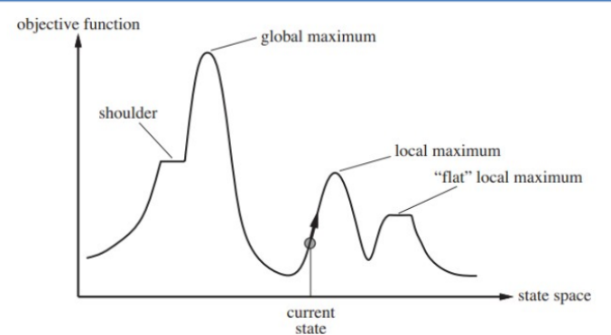
Unfortunately, hill climbing suffers from following problems:
• Local maxima: Local maximum is a state which is better than its neighbour states, but there is also another state which is higher than it. They are also called as
foot-hills. It is shown in Fig.
• Plateau: It is a flat area of the search space in which a whole set of neighbouring states (nodes) have the same heuristic value. A plateau is shown in Fig.
• Ridge: It’s an area which is higher than surrounding states but it cannot be reached in a single move. It is an area of the search space which is higher than the surrounding areas and that itself has a slope. Ridge is shown in Fig.
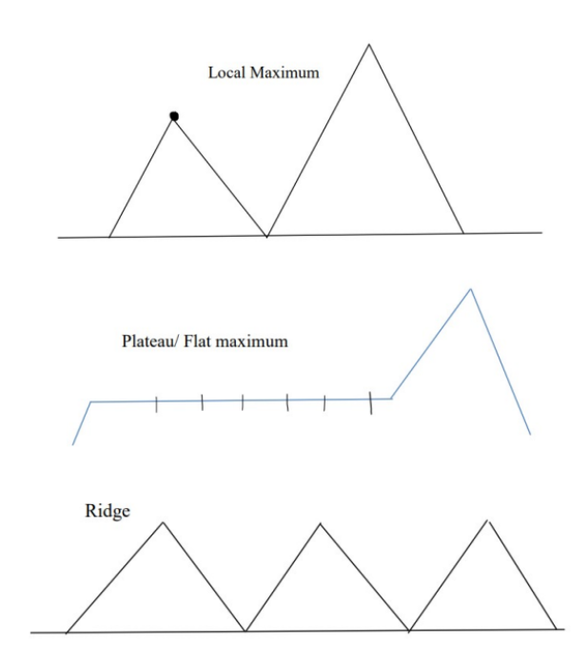
*Genetic algorithm :-
Genetic Algorithms (GAs) are adaptive heuristic search algorithms that belong to the larger part of evolutionary algorithms. Genetic algorithms are based on the ideas of natural selection and genetics. They are commonly used to generate high-quality solutions for optimization problems and search problems.
Genetic algorithms simulate the process of natural selection which means those species
who can adapt to changes in their environment are able to survive and reproduce and go
to next generation. In simple words, they simulate ― “survival of the fittest” among
individual of consecutive generation for solving a problem.
Each generation consist of a population of individuals and each individual represents a
point in search space and possible solution. Each individual is represented as a string of
character/integer/float/bits. This string is analogous to the Chromosome.

Steps of genetic algorithms:

Initial Population: The process begins with a set of individuals which is called a Population.
Each individual is a solution to the problem you want to solve. An individual is
characterized by a set of parameters (variables) known as Genes. Genes are joined into a
string to form a Chromosome (solution). In a genetic algorithm, the set of genes of an
individual is represented using a string, in terms of an alphabet. Usually, binary values are
used (string of 1s and 0s). We say that we encode the genes in a chromosome.

Fitness Function: The fitness function determines how fit an individual is (the ability of an individual to compete with other individuals). It gives a fitness score to each individual. The probability that an individual will be selected for reproduction is based on its fitness score.

Selection: The idea of selection phase is to select the fittest individuals and let them pass their genes to the next generation. Two pairs of individuals (parents) are selected based on their fitness scores. Individuals with high fitness have more chance to be selected for reproduction.

Crossover: It is the most significant phase in a genetic algorithm. For each pair of parents to be mated, a crossover point is chosen at random from within the genes. Offspring are created by exchanging the genes of parents among themselves until the crossover point is reached.

Mutation: In certain new offspring formed, some of their genes can be subjected to a mutation with a low random probability. This implies that some of the bits in the bit string can be flipped.

